**Design Document (Curve Selector)**

**Description:**

This document will go over basic User interface and what purpose each component serves. This web application will be SPA (Single Page Application) with two options in the header to upload and view (search) the curve files for Phase 1.

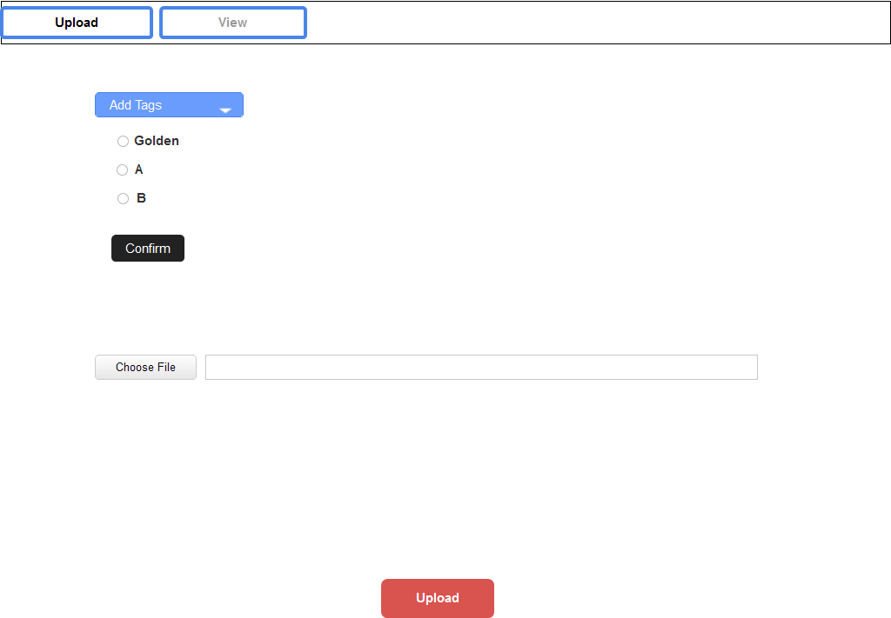**Upload Page:**

* “Add tags” dropdown will contain all the tags with radio so that multiple tags can be selected so that certain files can be multiple tags along with it.
* “Choose File” button will prompt the user a window to provide a path to certain files user would like to upload, and once path is chosen, the text field will display the path.
* “Upload” button will upload the files to the database and reset every field if there was no problem uploading. If no tags were selected, upload button will prompt user to add at least one tag.

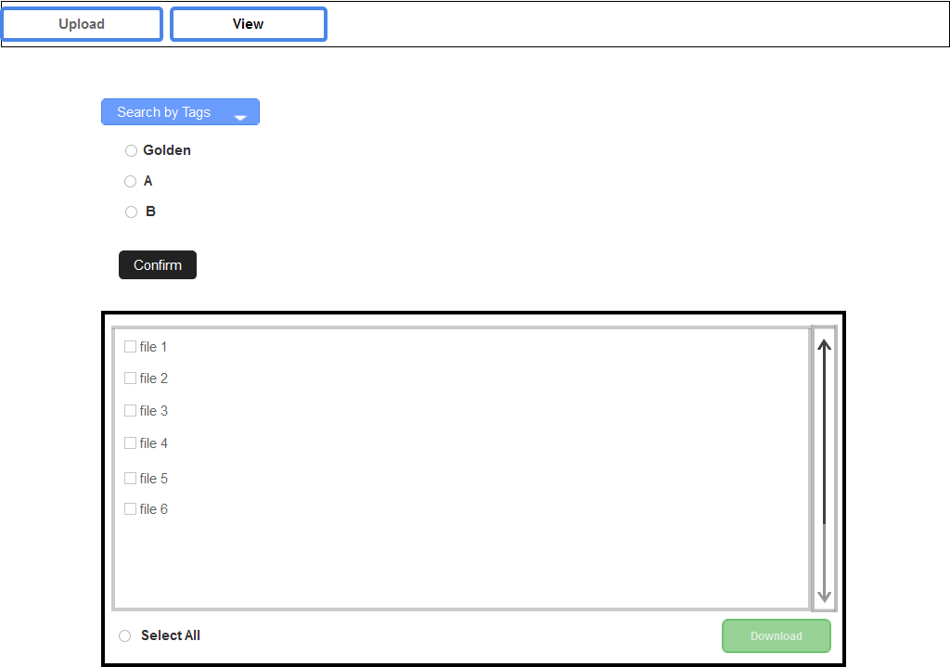**View Page:**

* “Search by Tags” button, similar to “add tags” button from Upload page, will have all the tags in similar manner.
  + Functionality
    - Tags selected will only query files with that certain tag(s)
    - For example,

Curve File 1 with tags (golden, A, B)

Curve File 2 with tag (A)

Curve File 3 with tags (golden, B)

***Search Query:***

golden => Curve 1 & 3

golden, A => Curve 1

* User can select all the files that come up or select specific files
* “Download” button will download the files and store it in user’s machine. In order to view the file, user has to download the first.